authors instructions

John S.Y. Tan*, Peggy Teo and Amanda Quek
*CI-Premier Pte Ltd
150 Orchard Road #07-14, Singapore 238841
e-mail: <cipremie@singnet.com.sg> webpage: http://www.cipremier.com

Keywords: Impact, fibre, RCC….

Abstract. This document presents the information and instructions needed to prepare a paper to be included in the proceedings of the 11th International Conference of the IFHS on Extreme Engineering.
In order to achieve graphical consistency, the paper should be written using Microsoft Word. The first page should start with the paper’s title, authors, corresponding affiliation, keywords and abstract. The abstract length should be kept under 400 words. If suitable, the introduction starts after the abstract.
1 introduction
The proceedings of the 11th International Conference of the IFHS on Extreme Engineering will include the full papers in soft format in a USB. All papers will be peer reviewed by the Conference Committees for acceptance to be published. Therefore, the corresponding author must send to the Conference secretariat:

a) The word processor file with all figures included and saved in the document. Avoid using non-standard fonts. No guarantee is given that these will print in another system besides yours.
b) A pdf format of the file.

2 general specifications
The contribution must be written in English with a print area of 16 x 25 cm, centered in the page. All contribution will be reviewed, in the form offered, and eventually published. Their length must generally be maximum (10 pages for technical papers and 16 pages for keynote papers).
3 title, AUThORS, affiliation, keywords
The first page must start with the title, authors’ names, first author affiliation, address, e-mail and webpage (if applicable), followed by keywords and abstract. Second, third and other authors’ affiliation should be included in a footnote. The first line of the title starts 3 cm below the upper edge of the print area. This is 4 cm below the upper edge of the page, A4 paper should be used.

3.1 Title
The title must be centered and written in uppercase using 14 point Arial bold font, and the lines must be single spaced.

3.2 Authors
The authors’ names must include the first name, middle initials (if it is the case) and the last name. These must be centered and written with 11 point Arial bold font. The authors’ names must be located 11 point below the last title line.

3.3 Affiliation
The first author affiliation must be centered, written with 11 point Arial, and located 11 point below the authors’ names.

3.4 Keywords
Up to six keywords must be provided. These are written with the Arial 11 point Arial in justified lines. The expression Keywords, written in 11 point Arial bold font must start the first line of keywords. The keywords must be spaced from the last line of the affiliations by 12 point.

3.5 Abstract
The typeface used for the abstract is a 12 point italic Arial. The word Abstract, written in 12 point bold Arial, must appear in the beginning of the first line. The abstract text is justified and written 12 point below the last line of the keywords, as shown in the first page of these instructions.

4 sections

4.1 Main sections
The titles of the main sections must be flushed left and written with uppercase bold Arial 10 point font. A 12 point space before and a 6 point space after the section title must be specified. In order to avoid orphans on the text make sure that at least three lines of text are typed after the section title and before any page break. The graphical appearance of the publication will profit from your care.

4.2 Subsections
The subsection titles must be written flushed left, with a bold Arial font, 10 point. Only the first letter of the title is uppercase, being all others lowercase. Spaces of 12 point before and 6 point after the subsection titles must be specified. In order to avoid orphans on the text make sure that at least three lines of text are typed after the subsection title and before any page break.

5 headers
As shown in the first page of the instructions, a header with the Conference name, venue and dates will be included in the preprints. All other pages will have in the headers the authors’ names. Please make sure that you comply with the headers of all pages. If the header of the first page is not included according to the instructions, that shall be added.

6 TEXT
The normal text of the contribution must be typed single spaced, justified, and using 10 point Arial font. Moreover the text must be in a single column. The first line of each paragraph must be indented 0.5 cm and no additional spacing between paragraphs must be given.
7 page numbers
The page numbers should be included by the authors. The page number must be centered and placed below the print area (not inside).

8 figures
All figures must be numbered consecutively and have a corresponding caption, as shown in Figure 1. The caption is centered and written using 10 point Arial, using upper and lowercase. The distance between each figure and its corresponding caption must be 6 point while the distance from the top of the figure and from the caption to the text must be 12 point. The figures must be included in the text. Do not supply the figures in the end of the paper.
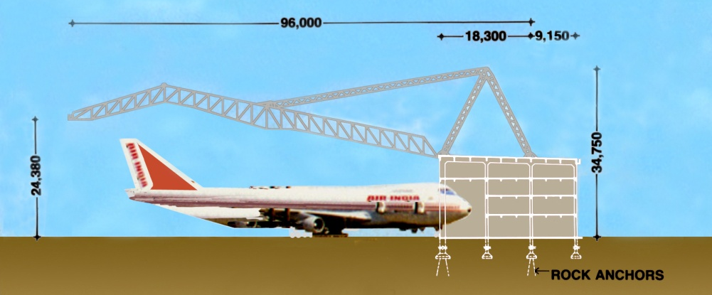
Figure 1: Air India 747 Jumbo Jet Hangar

9 equations
Each equation must be numbered in a sequential fashion, using Arabic characters included in parenthesis. The equations must be centered and a 6 point space between the text that precede and follows them must be given. The following is an example of an equation in a single line:
(1)
The following is an example of equations that occupy consecutive lines:
(2)
10 tables
All tables must be numbered consecutively and have a corresponding caption. The caption is centered and written using 10 point Arial, using upper and lowercase.

Column 1 | Column 2 | Column 3
C11 | C12 | C13
C21 | C22 | C23
C31 | C32 | C33
C41 | C42 | C43
C51 | C52 | C53
Table 1: Example of a table construction.
The distance between each table and its corresponding caption must be 6 point while the distance from the top of the table to the text above and from the caption to the text below must be 12 point. The tables must be included in the text.

11 format for the references
In the text, the references must be provided using superscripts , and grouped in the end of the paper by numerical order, as shown in the end of these instructions. The numbering by which they are referred must also be consecutive and by the order they appear in the text.

12 conclusions
Full papers (prepared in Microsoft Word and pdf formats) for review must be sent by e-mail to ci-p@cipremier.com not later than 30 June 2019.

Papers received after 15 July 2019 (if not reviewed) may not be included in the proceedings.

references

Second Institution Name
Third Institution Name
[] R.E. Roberson and R. Schwertassek, Dynamics of multibody systems, Springer-Verlag, Berlin, Germany (1988).

